Ideation Phase
Brainstorm & Idea Prioritization Template
Date | 01 September 2026
Team ID | Individual Project
Project Name | Software Installation Request Automation in ServiceNow
Maximum Marks | 4 Marks
Brainstorm & Idea Prioritization Template:
Brainstorming provides a free and open environment that encourages creative thinking and problem solving. For this individual project, the same ideation process is completed independently to generate, group and prioritize ideas for the Software Installation Request Automation in ServiceNow project.
Use this template in your own brainstorming session so the project concept can be shaped systematically.
Reference: https://www.mural.co/templates/brainstorm-and-idea-prioritization
Step-1: Team Gathering, Collaboration and Select the Problem Statement
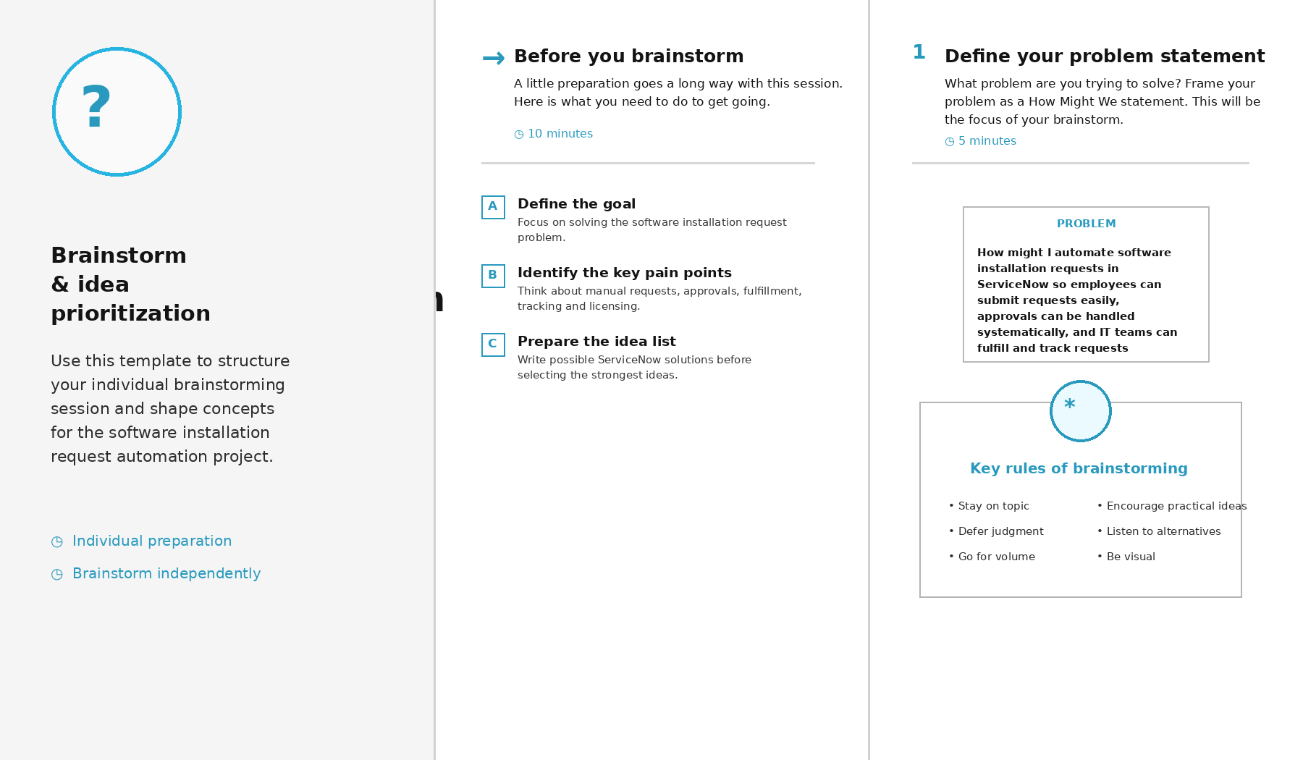

Step-2: Brainstorm, Idea Listing and Grouping
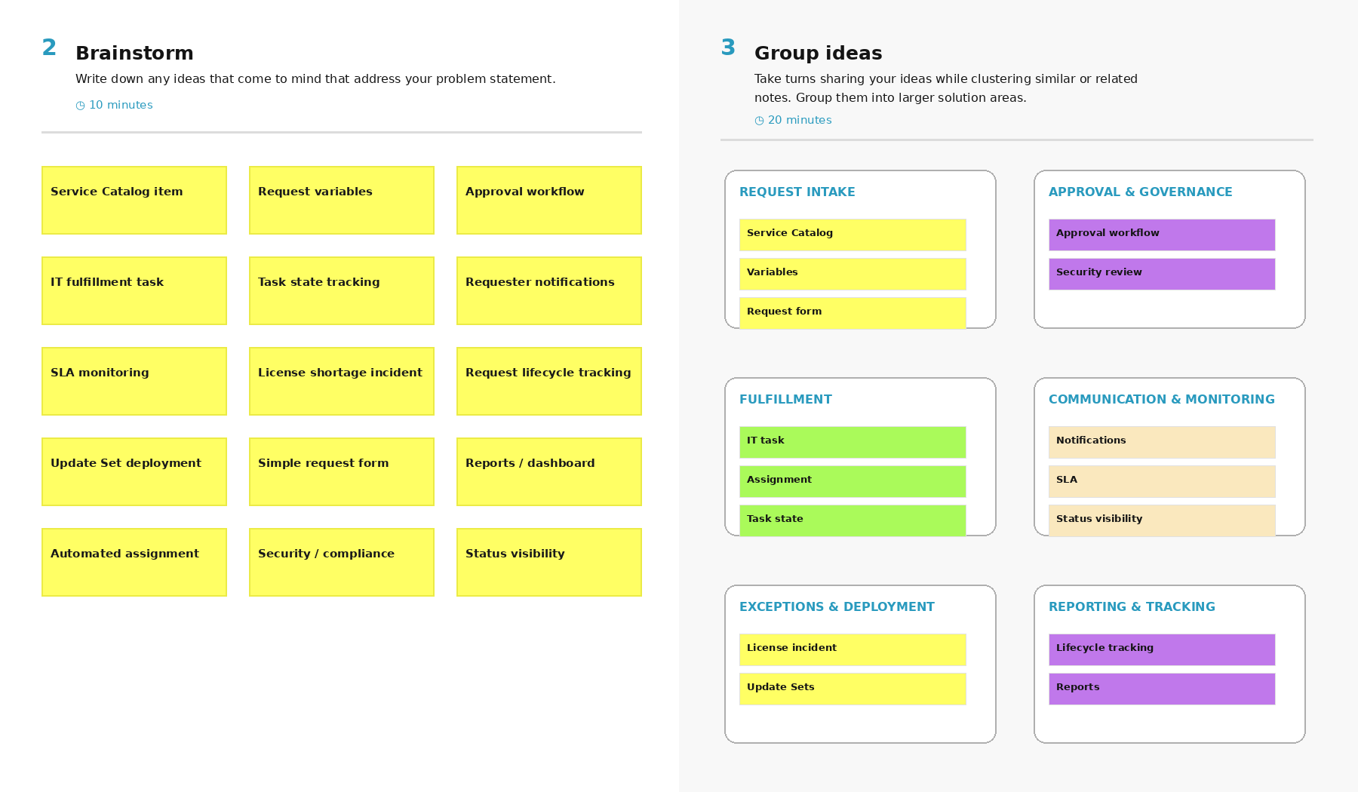
Step-3: Idea Prioritization
